Katsumi Fujita

CMSC141

Dr. Greg Grinberg

April 1, 2024

Practice Section 1

Part 1: Creating Github account.

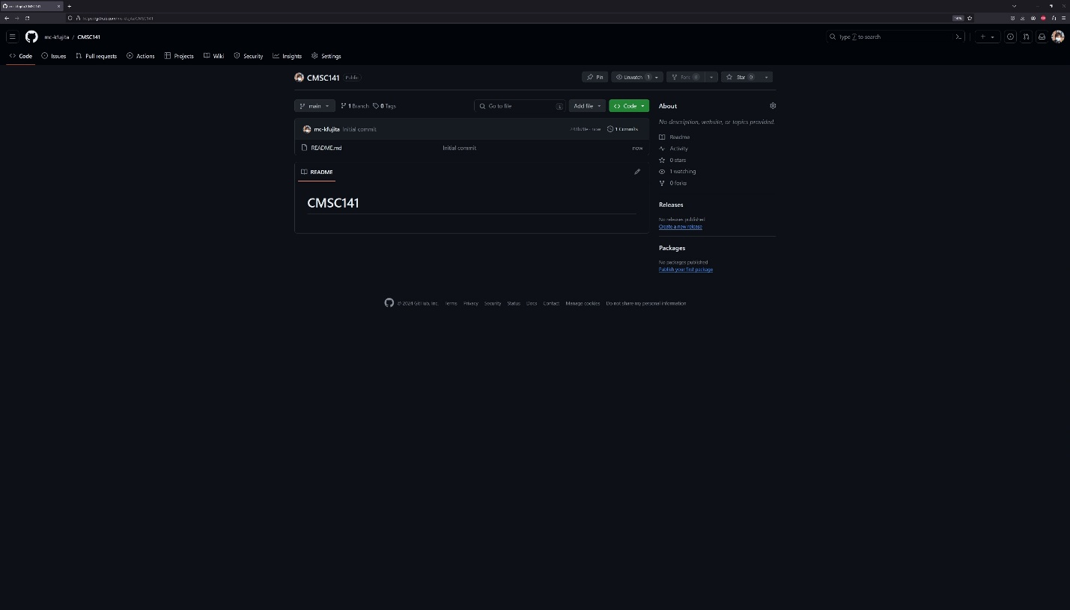

Part 2: Installing the latest JDK and running java file on Command Prompt.

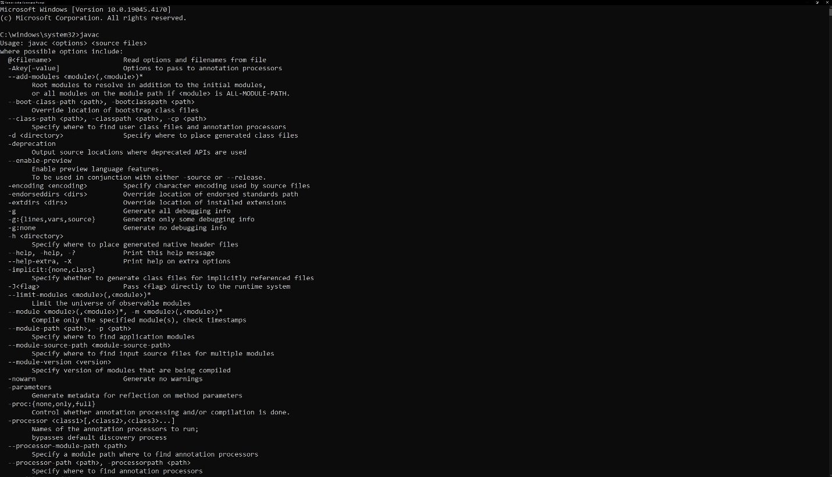

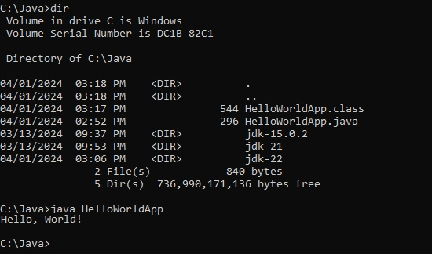

Part 3: Installing the latest Eclipse IDE

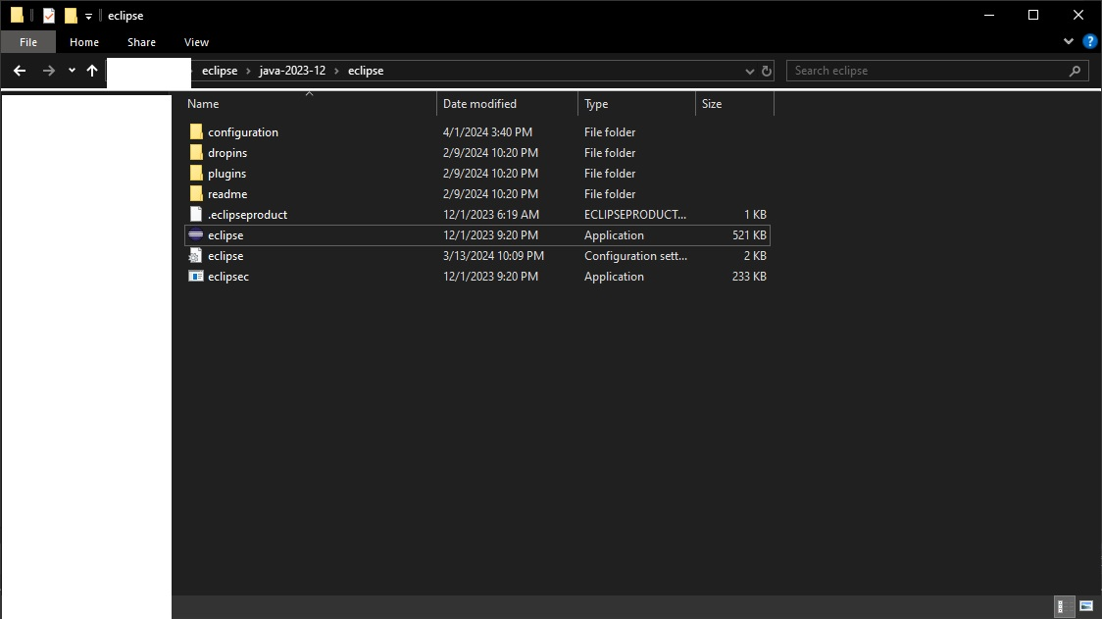

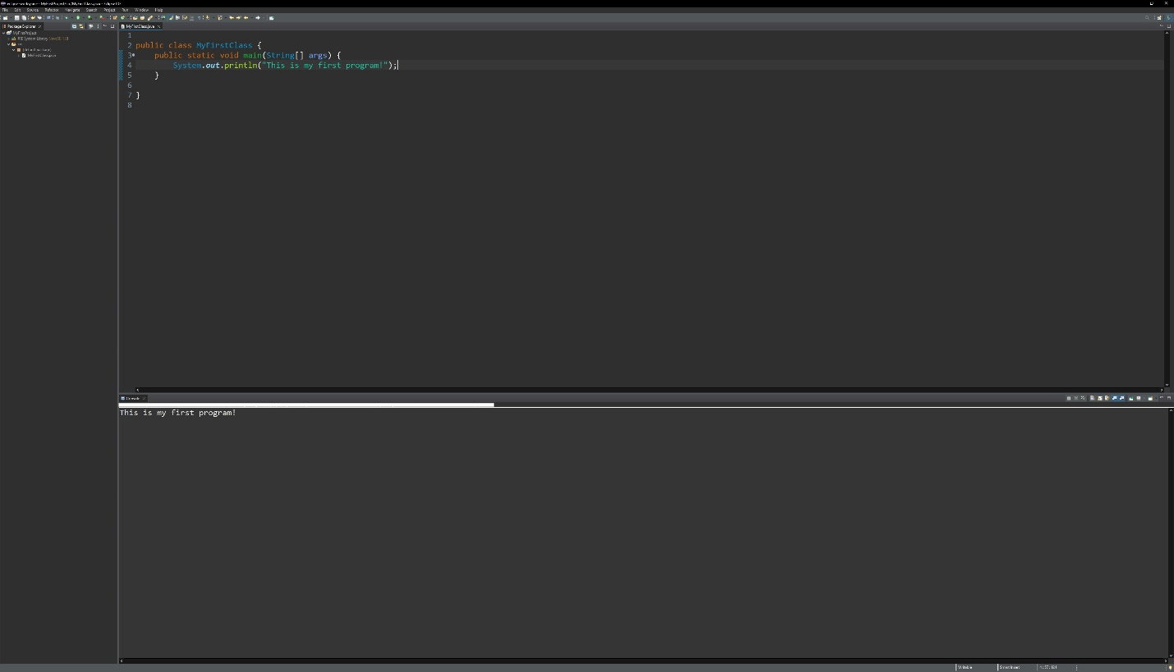

Part 4: Getting started with Eclipse IDE



Java Fundamentals

# 4-1: Getting Started with Eclipse Practice Activities

**Lesson Objectives:**

* Identify components of Eclipse
* Identify components of a Java application
* Compile an application
* Test to ensure application is complete
* Write the code for GalToLit.java
* Modify a program to execute error free
* Modify a program to use a formula to convert units of measure

**Vocabulary:**

Identify the vocabulary word for each definition below.

|  |  |
| --- | --- |
| Camel case | A naming convention to eliminate spaces in a name, but to ease readability with capitalization. |
| Switch workspace | To change the different physical location onto which you will store and save your files. |
| Java package | Stored inside a project, a mechanism for organizing Java classes into namespaces, or containers. |
| Main method | The method inside a class that runs when the class is compiled and ran. |
| Class(Java) | A construct that is used as a blueprint to create objects. Also a construct in which objects are created. |
| Open perspective | An option to choose a combination of views and editors. |
| Edit and View areas in Eclipse IDE | Areas within the Eclipse IDE that provide a way to navigate a hierarchy of information and allow modifications to elements. |

**Try It/Solve It:**

* 1. Create a presentation to highlight five or more Views that may be of interest to a programmer using Eclipse. Use the help system to learn about the Views available in Eclipse. Work in teams of two to create and deliver the presentation. The presentation should include the following:
     1. A presentation introduction defining the presentation purpose and the team members.
     2. A list of five or more Views in Eclipse that will be highlighted.
     3. The reason your team selected the five Views to demonstrate.
     4. The process your team went through to choose the five Views.
     5. The actual demonstration and description of the components.
     6. The presentation summary.



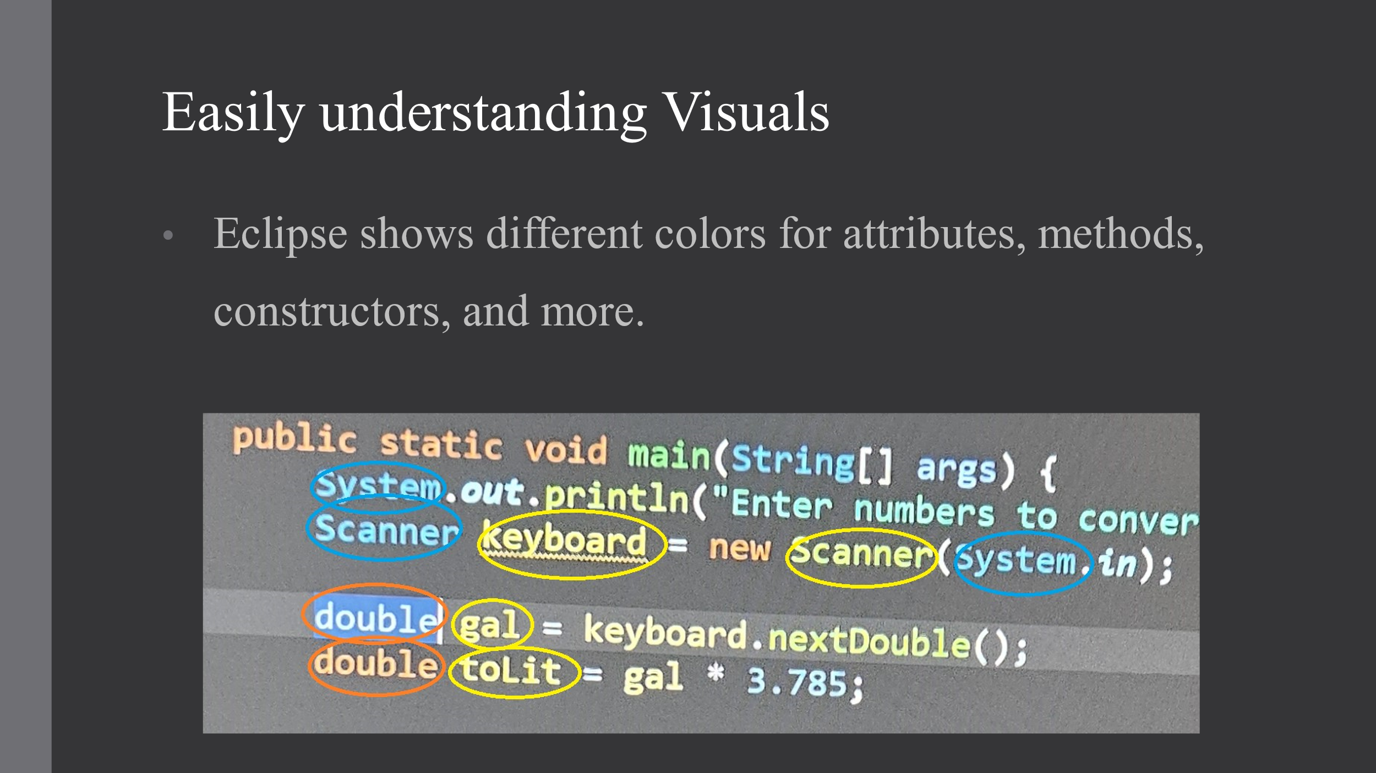

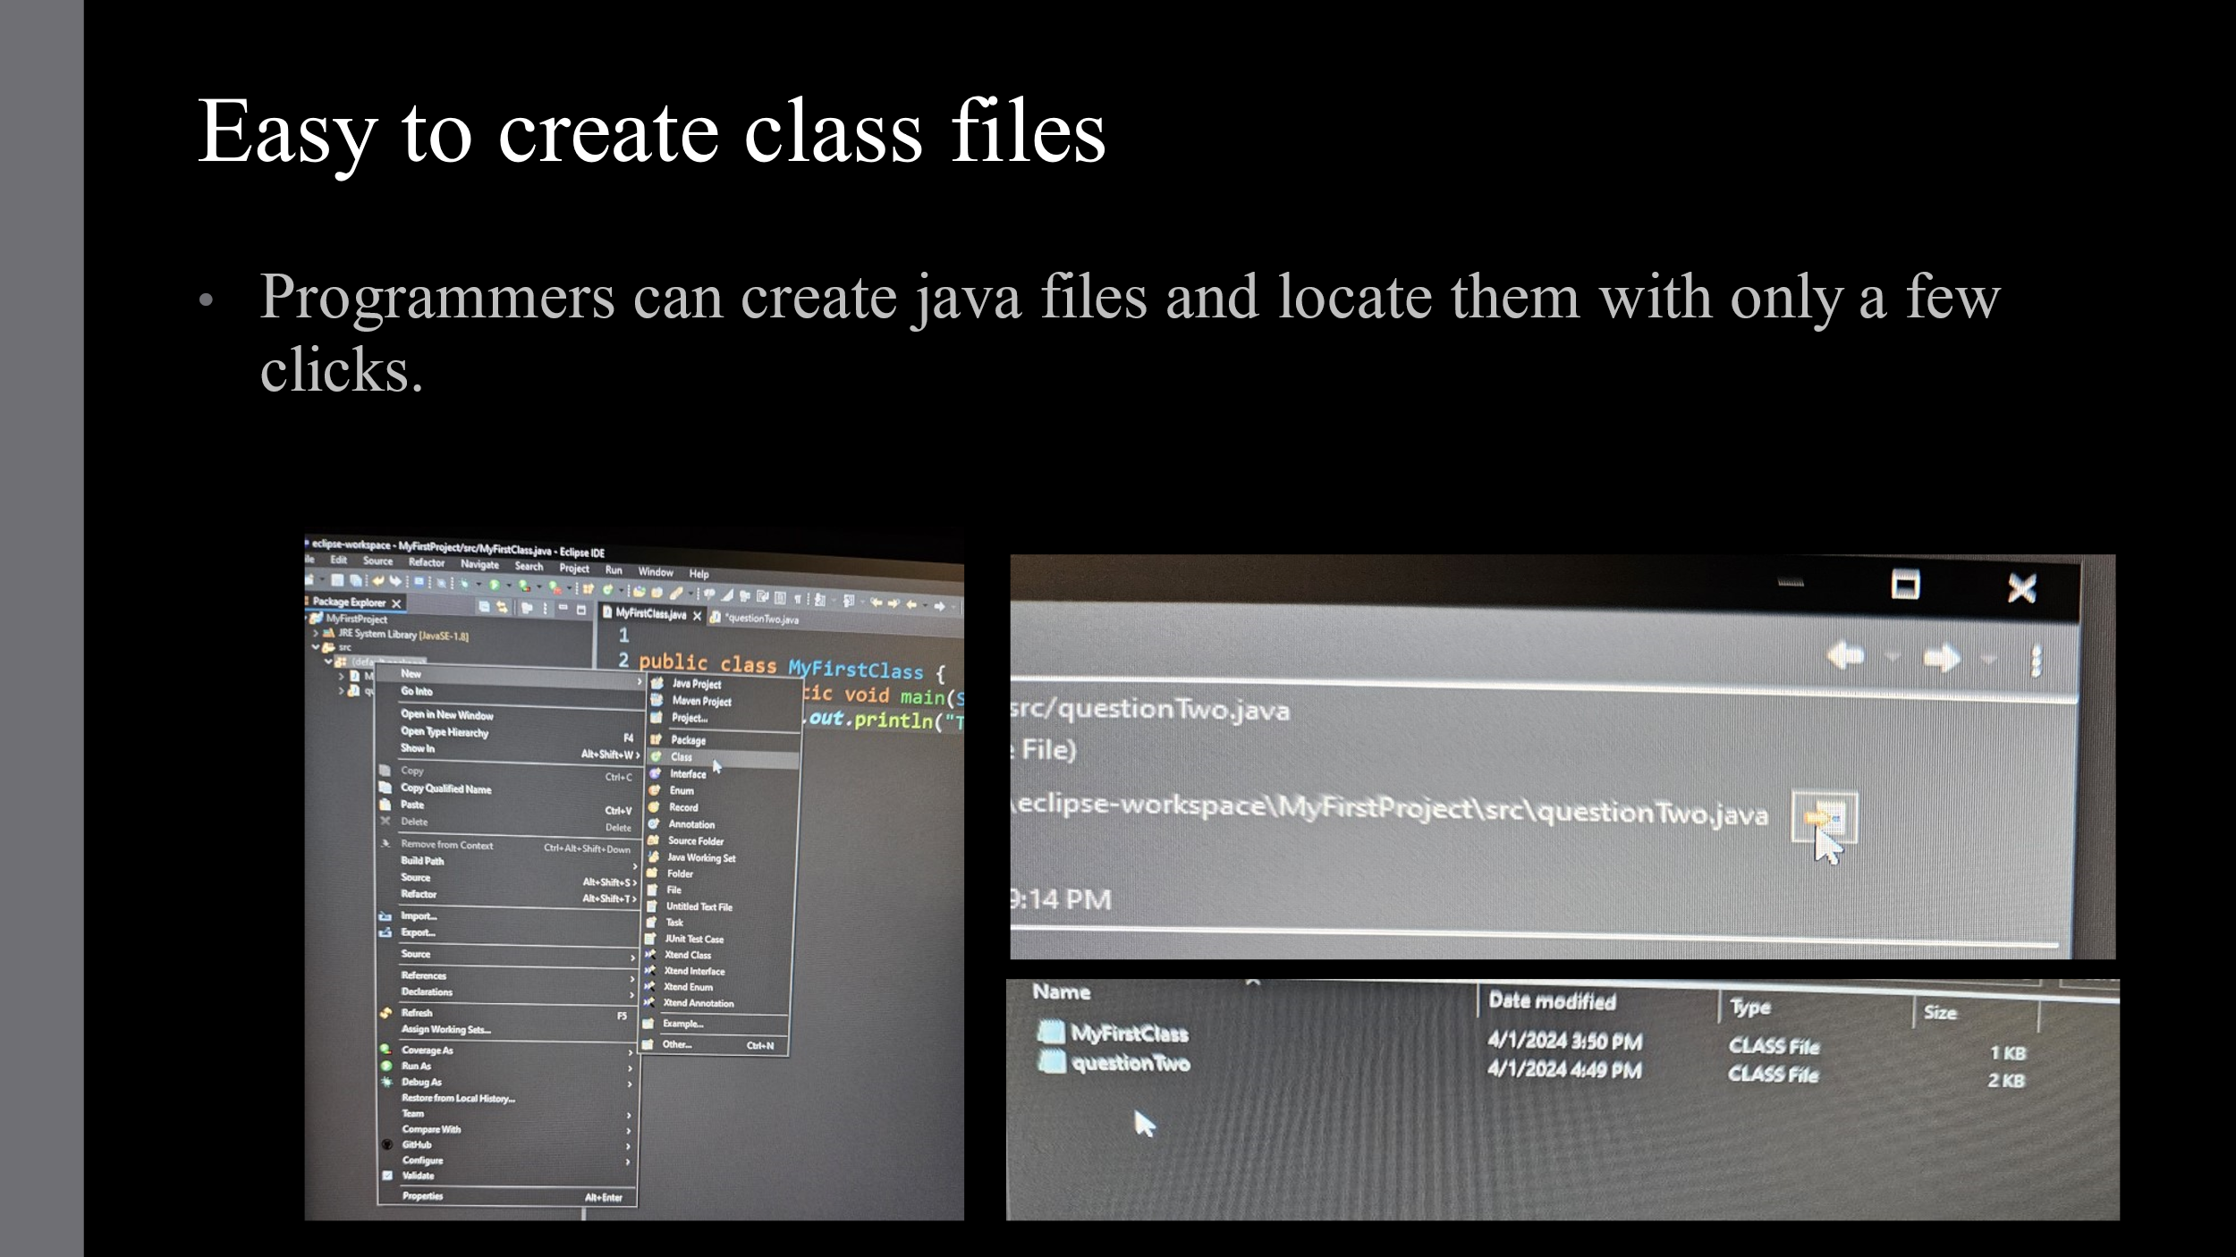

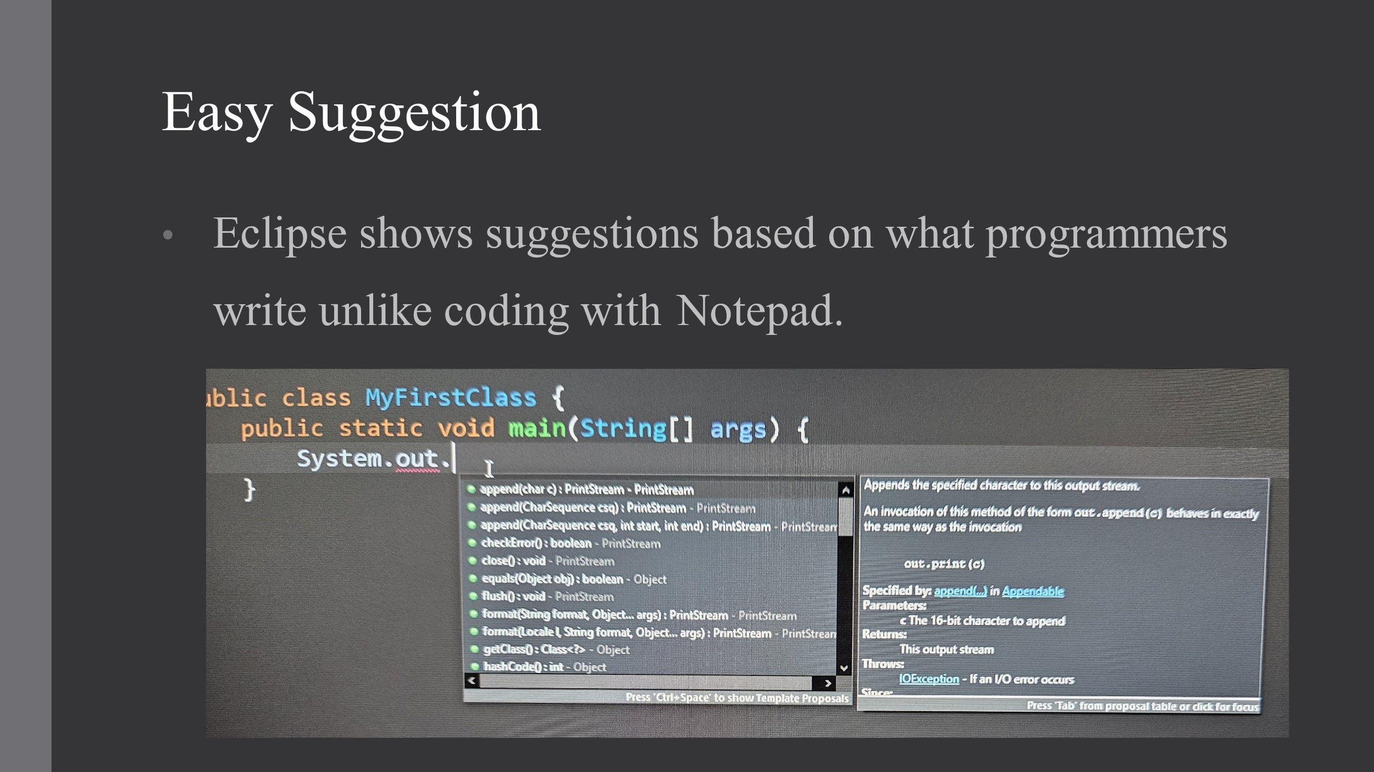

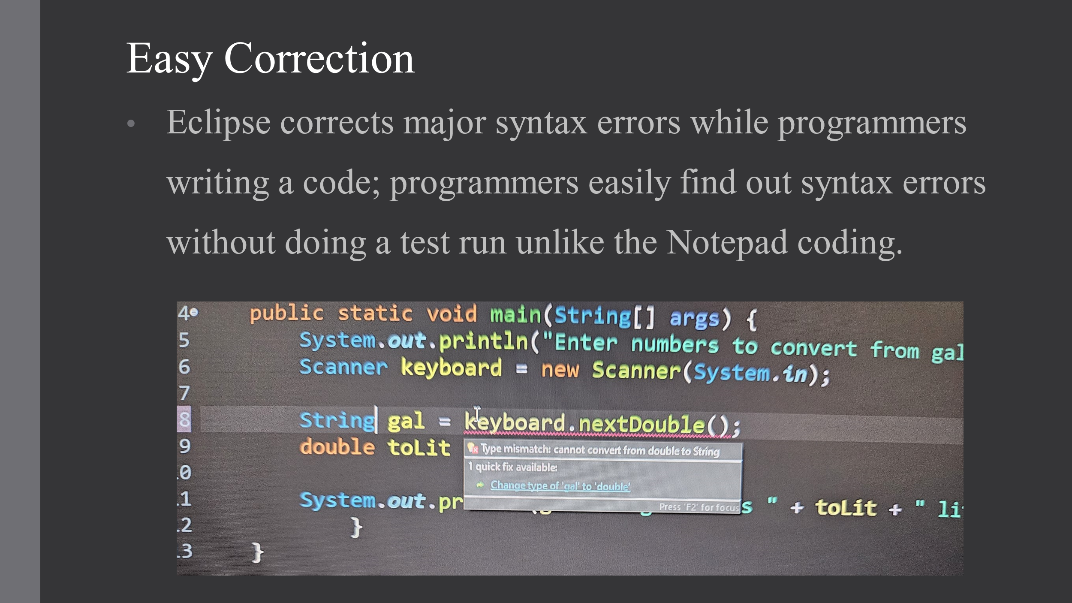

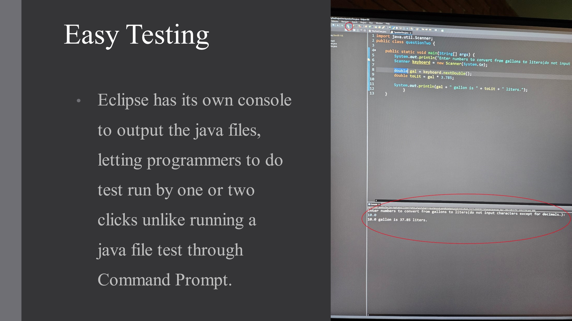

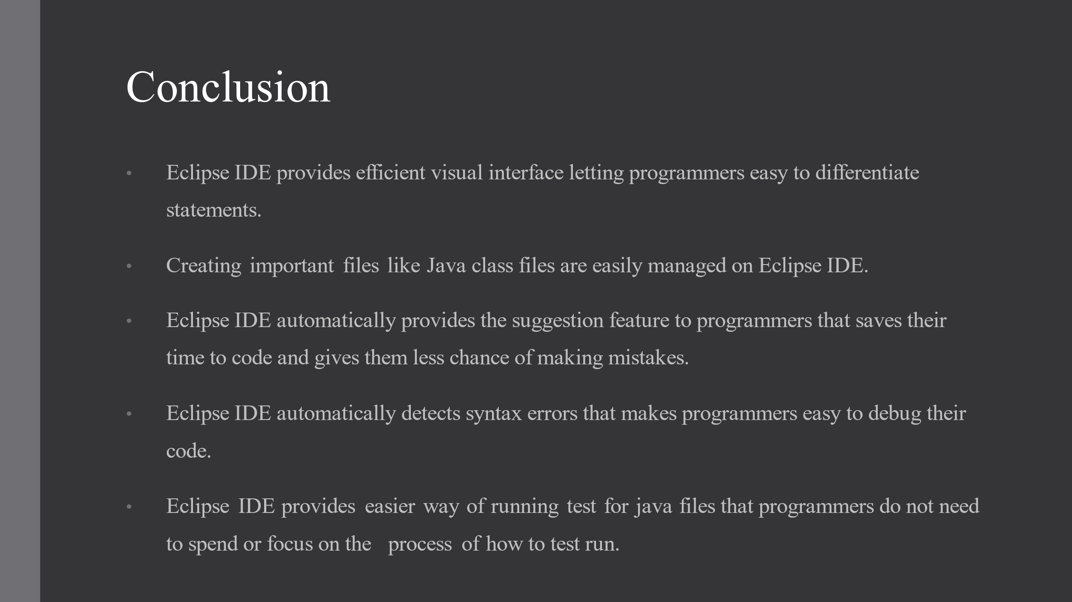

Copyright © 2020, Oracle and/or its affiliates. All rights reserved. Oracle and Java are registered trademarks of Oracle and/or its affiliates. Other names may be trademarks of their respective owners.

* 1. The pseudo code for converting gallons to liters was described in the lesson. Write the code for the program. The program will convert a specific number of gallons to liters and then display the output.

Create public class questionTwo{} to create class.

Inside the class, create public static void main(String[] args){} to create main method.

Inside the main method, create two attributes of double gal = 1 and double toLit = gal* 3.785 to set the value for gallon and converting equation.

Inside the main method, output the result by System.out.println(gal+“ gallon is ” + toLit+ “liters.”). “gal” will output the double value of the gal, “toLit” will output the converted value from int gal to litters accordingly to the implemented equation, use“” to output texts, and use + to connect the output of the double gal value, double toLit value, and texts of “” altogether within the same System.out.print line.

* 1. Modify the code written in step 2 to prompt a user for the number of gallons to compute.

First, adding the line of import java.util.Scanner; before the class questionTwo{}.

Implement public class questionTwo{} to create class.

Implement public static void main(String[] args){} to create main method within the class.

Add System.out.println(“Enter numbers to convert from gallons to liters. Please do not input characters except for decimals: “); and Scanner keyboard= new Scanner(System.in); to let users input. Implement attribute of double gal= keyboard.nextDouble(); to set the gal is equal to the user input, then implement the attribute double toLit= gal* 3.785; to set the double as gallon-litter converter. After that, use system.out.println to output the result.

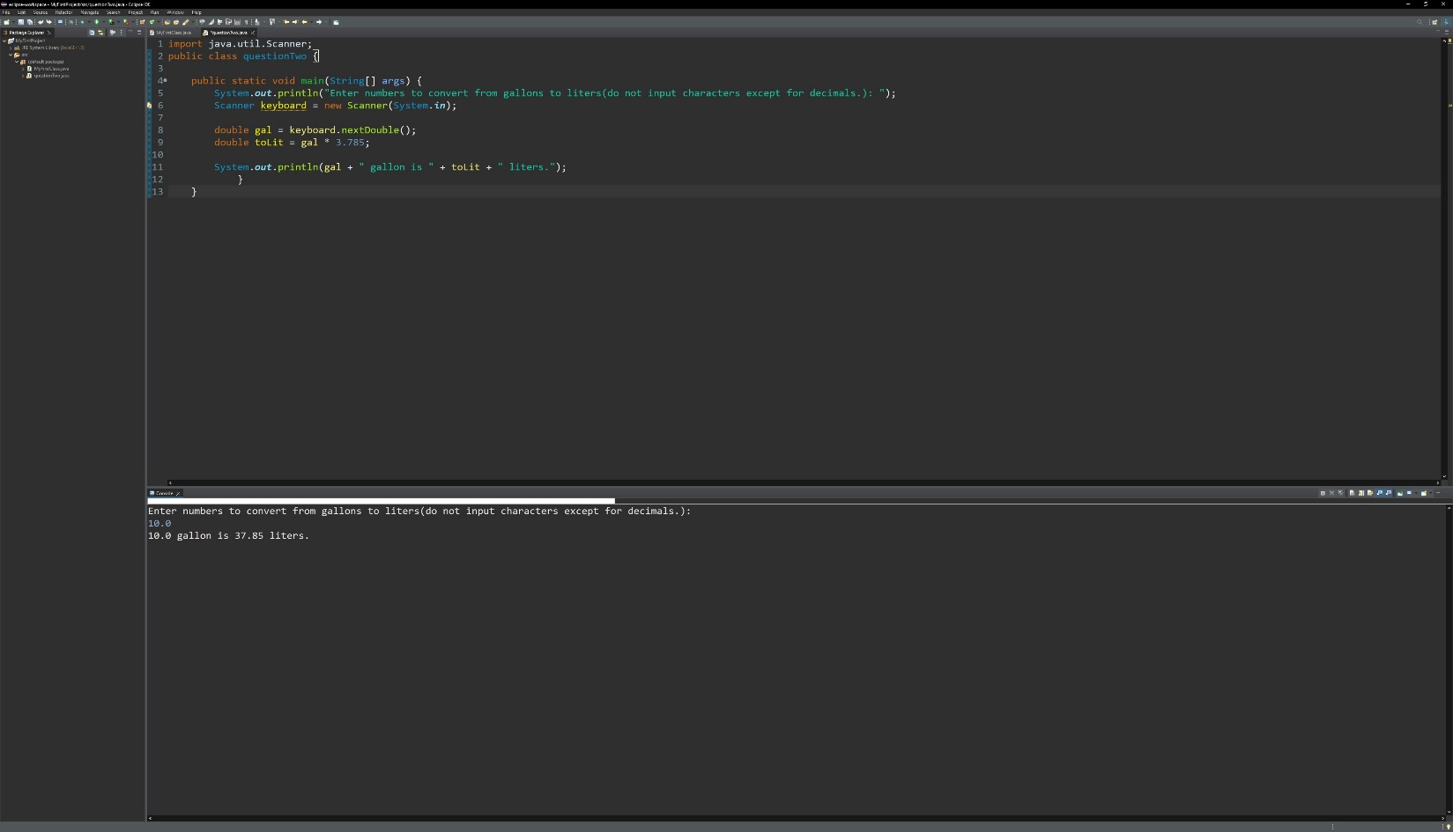

* 1. Describe three ways you can test the program that converts gallons to liters.

Using either Command Prompt or Eclipse IDE to test run the java file if the converter containing code file is working properly.

Input 0 as the gallon number to see if the number of liters is 0.0.

Input 1 as the gallon number to see if the number of liters is 3.785.

Input 10.0 as the gallon number to see if the number of liters is 37. 85.

Copyright © 2020, Oracle and/or its affiliates. All rights reserved. Oracle and Java are registered trademarks of Oracle and/or its affiliates. Other names may be trademarks of their respective owners.